1. HYDROPONICS APPLICATIONS AND ANCILLARY MODIFICATIONS TO A POLYPHASIC PRESSURIZED HOMOGENZER
2. Introduction

* Ancillary embodiments and modifications to a homogenizer unit (“PPH'), and methods of use directed to hydroponics.
* The apparatus includes a homogenizer body, one or more nutrient stream inlets, one or more water inlets, a mixing Zone where the water stream is commingled with the nutrient stream, and a venturi within the body immediately down stream from the mixing Zone such that the commingled streams are pulled into the Venturi resulting in homogenization.
* The PPH components are insulated to maintain the aqueous nutrient Solutions cooled, below ambient temperature.
* The resulting aqueous nutrient solution can be conveyed in its cooled State to roots of hydroponically grown

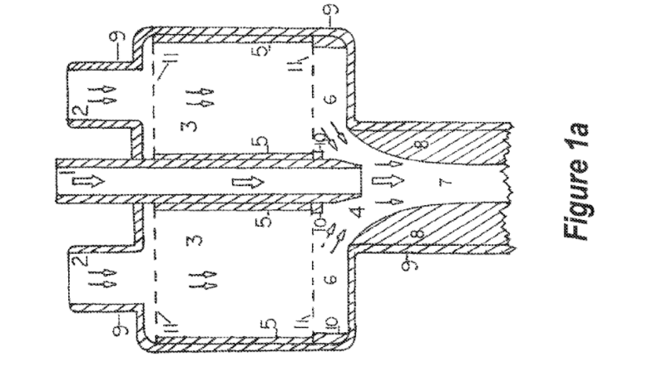

1. Description

* modified homogenizer unit includes an integrated unit having a much expanded housing that is intended to contain a replaceable ante-mixing chamber containing various packings, baffles, and/or sorbents.
* The housing (9) also has top mounted ports.
* The central port (1) is dedicated to the input of water or a similar solvent mixture.
* One port or several ports (2) is/are dedicated to entry of a gas, gases, liquid, liquids, any type of particle or mixture of particulates that will pass through the port, the ante-mixing chamber or mixing chamber,
* The components are numerically identified as it follows:

1. water or other solvent intake port and jet or nozzle
2. pollutant stream port or ports
3. ante-mixing chamber
4. mixing chamber
5. ante-mixing chamber housing
6. lateral extent of mixing chamber
7. venturi throat
8. Venturi
9. homogenizer housing
10. ante-mix chamber support
11. ante-mixing chamber screen Supports.

* Headspace modifications or embodiments may include a mechanical mixer, mounted on a shaft, driven by an electric motors
* The solution enters the headspace region by one or more ports by passing through a perforated bulkhead, that is mounted within the homogenizer housing
* A single transfer tube or line allows for passage of a solution into the headspace of the homogenizer
* Mixing may be done by a mechanical mixer or by casual mixing while flowing into the ante-mix chamber. This port(s) may be positioned on the homogenizer housing or one or all intake ports other than water
* ante-mix chamber may be cylindrical in structure and fit tightly within the ante-mixing chamber and directly superior to the mixing chambers of the homogenizers
* ante-mixing chambers depicted include the exterior housing, the interior housing the top and bottom support screens
* ante-mixing chambers are Supported both laterally and centrally by circular ante-mixing chamber Supports
* perforations in the upper and lower screens of the ante-mixing chambers may have a variety of designs ranging from hexagonal, circular, square, to diamond-shaped
* These perforations allow for circulation of gas through them while containing and Supporting the various packings within the chambers
* These packings are varied in configuration and may be Bioballs or any other similar configuration, baffles, having any configuration, cross-section, and Surface treatment
* Water and a solvent or solvents containing water and another reactive chemical is delivered to the mixing chamber by a jet or jets
* homogenizer unit mixing chamber is positioned between the jet(s) and above the Venturi(s) of the homogenizer unit(s)
* Although the boundaries of this mixing chamber are not well-defined, this region is the uppermost area wherein the solvents begin to mix before entering the throat
* It is within the venturi that the solvents come into intimate contact with each other
* smooth venturi surface is one option, while a circularly ridged or grooved surface, a surface with vertical vanes allows for furthering certain reactions, and a radially-grooved surface can be used.
* Mixture continues in the retention chamber which may have a series of spherical chambers, be baffled, have a centrally located spiral conduit, or the serial spherical chambers may have a centrally-located spoiler ball or bead
* the extreme lower end of the retention chamber has four, equi-spaced lateral discharge ports.
* These ports can be produced into tubular form, or continued on to form a j-tube
* result in the increase of safety margins by containing the chemical and physical reac tions within an aqueous medium, thereby both containing out-gassing and heat generation from exothermic reactions while also cooling any such reaction by rapidly diluting the reactantS.
* One embodiment is directed to apparatus and methods that may be employed for introducing nutrients into a water stream to provide an aqueous nutrient Solution for hydroponics plant growth
* Such a PPH apparatus may be any of those configurations described herein, and in one embodiment may further include an insulated jacket around Such components as the inlets, the ante-chamber, the venturi, and the outlet to maintain the nutrient solution at temperature below ambient temperature so as to increase dissolution of oxygen, nitrogen, or both into the aqueous nutrient solution. Where a retention chamber is provided within the PPH, it of course may also be insulated.